Fast Discerning Repeats in DNA Sequences with a Compression Algorithm
E. Rivals, M. Dauchet, J-P. Delahaye, and O. Delgrange
In Proceedings of 8th Workshop on Genome Informatics (GIW 97), pages 215--226.
Abstract
- Introduction
- Coding of repeats and optimal compression
- Heuristic factorization algorithm
The choice of the repeats aims at maximizing the compression gain (of a zone) and is based on two genetically sound criteria: 1) the length of the repeats. 2) the absence of overlap between those repeats.
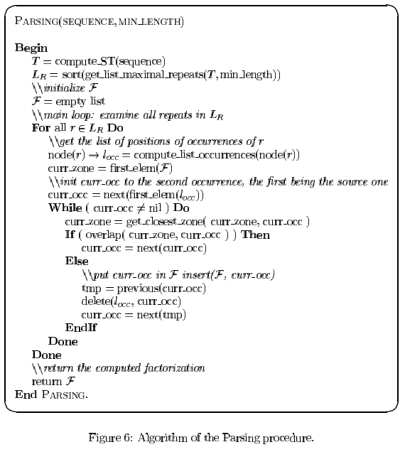
- Summary and conclusions
Created by: Ming-Cheng Lin
Date: Jan. 2, 2001

